Area of largest rectangle in Histogram
Problem Statement: Given an array of integers heights representing the histogram's bar height where the width of each bar is 1 return the area of the largest rectangle in histogram.
Example:
Input: N =6, heights[] = {2,1,5,6,2,3}
Output: 10
Explanation:

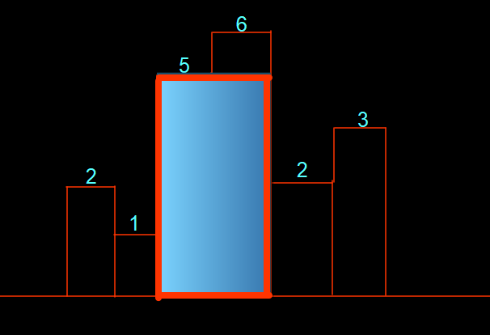

Solution 3: Optimised approach 2
Intuition:
This approach is a single pass approach instead of a two-pass approach. When we traverse the array by finding the next greater element, we found that some elements were inserted into the stack which signifies that after them the smallest element is themselves
So we can find the area of the rectangle by using arr[i] * (right smaller - left smaller -1 ).
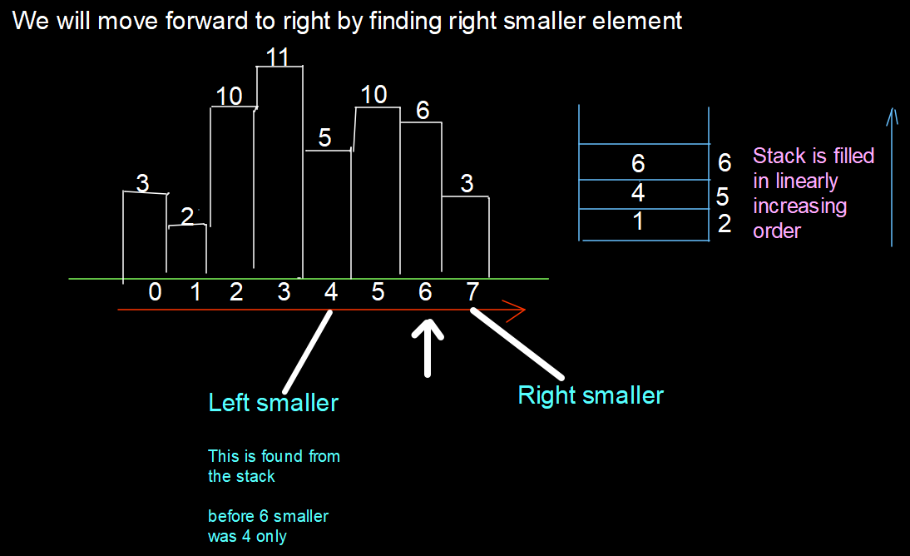
Approach:
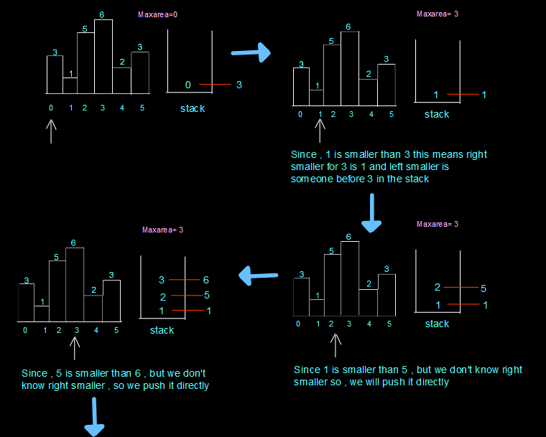
class TUF {
static int largestRectangleArea(int histo[]) {
Stack < Integer > st = new Stack < > ();
int maxA = 0;
int n = histo.length;
for (int i = 0; i <= n; i++) {
while (!st.empty() && (i == n || histo[st.peek()] >= histo[i])) {
int height = histo[st.peek()];
st.pop();
int width;
if (st.empty())
width = i;
else
width = i - st.peek() - 1;
maxA = Math.max(maxA, width * height);
}
st.push(i);
}
return maxA;
}
}
Time Complexity: O(N) + O(N)
Space Complexity: O(N)

